Norfolk County Council (Bracon Ash and Hethel)
Emergency Notice

Temporary Traffic Regulation Order 2026
Section 14(2) of the Road Traffic Regulation Act 1984

Bracon Ash and Hethel (STRO14209) Notice

In accordance with the provisions of Section 14(2) of the Road Traffic Regulation Act 1984, the Norfolk County Council HEREBY GIVE NOTICE that owing to a burst water main the use by vehicles (of any class) of the C179 East Carleton Road from its junction with B1113 Norwich Road for 500 metres north-westwards (the “Road”) in the Parish of Bracon Ash and Hethel will be temporarily prohibited/restricted.

Alternative route is via: Norwich Road, East Carleton Road, Scotts Hill, Rectory Road, Catbridge Lane (East Carleton and Ketteringham, Mulbarton, Bracon Ash and Hethel).

The works promoter for this restriction/closure is: Anglian Water.

The closure/restriction is necessary because of the likelihood of danger to the public or serious damage to the road or both.

The closure/restriction is anticipated to take place from 4th to 10th February 2026 but the Road may continue to be closed/restricted until the 24th February 2026 where the closure/restriction is still required beyond the anticipated dates.

This Notice shall automatically revoke on the completion of the works / when the closure/restriction is no longer necessary or otherwise on the 24th February 2026 without further notice.

If necessary, this Notice may be extended for an additional 21 days by further Notice and/or for a maximum of 18 months from the date this Notice is effective by further Order.

A person who contravenes, or who uses or permits the use of a vehicle in contravention of the restriction/ closure imposed by the Order shall be guilty of an offence.

Penalty: £1000 maximum fine on conviction and/or endorsement for contravention.

Full details on the closure are available at https://one.network. Any enquiries that cannot be answered on the one.network website should be directed to the South Area Streetworks (Infrastructure Department) contactable by telephone at 0344 800 8020 or email at streetworks@norfolk.gov.uk

Dated this 5th day of February 2026.

Katrina Hulatt
Director of Legal Services (nplaw)
County Hall
Martineau Lane
Norwich
NR1 2DH

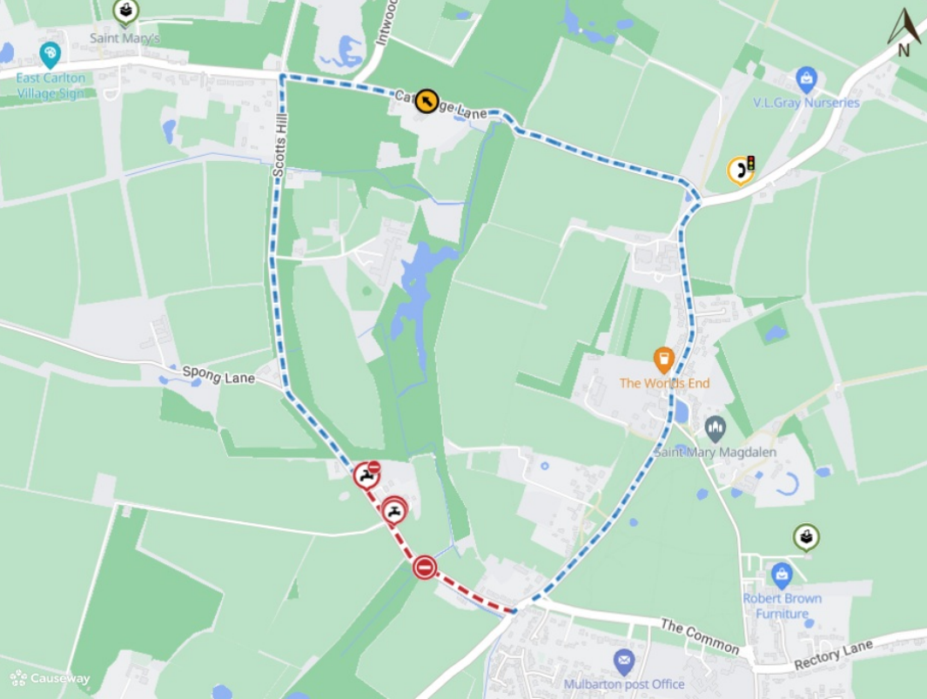

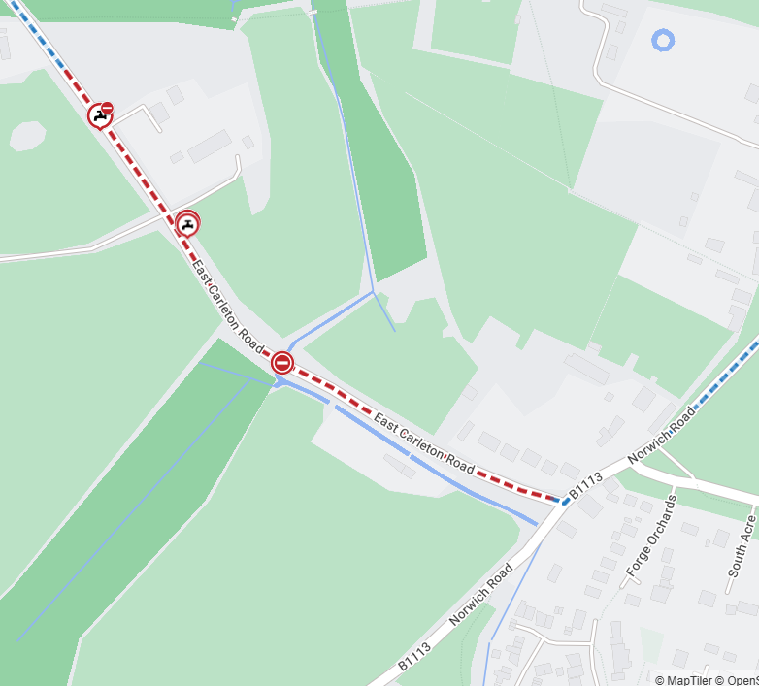
Imagery © 2026 MapTiler | Imagery © 2026 Hexagon | © MapTiler © OpenStreetMap contributors

