Norfolk County Council (Tharston and Hapton)
Urgent Notice

Temporary Traffic Regulation Order 2026
Section 14(2) of the Road Traffic Regulation Act 1984

Tharston and Hapton (STRO14026) Notice

In accordance with the provisions of Section 14(2) of the Road Traffic Regulation Act 1984, the Norfolk County Council HEREBY GIVE NOTICE that owing to pole testing works the use by vehicles (of any class) of the C497 Bungay Road from 200 metres east of its junction with U76028 Parkes Lane for 120 metres eastwards (the “Road”) in the Parish of Tharston and Hapton will be temporarily prohibited/restricted.

Alternative route is via: Low Tharston, The Street, Fundenhall Road, Hapton Road, B1113 The Turnpike, Norwich Road, Main Road, Mulbarton Road, A140 Ipswich Road, Norwich Road, Bungay Road and vice versa (Swainsthorpe, Mulbarton, Wreningham, Bracon Ash, Keswick and Intwood, Stoke Holy Cross, Ashwellthorpe and Fundenhall, Tasburgh, Saxlingham Nethergate, Long Stratton, Swardeston, Caistor St. Edmund and Bixley, Tharston and Hapton, Newton Flotman).

The works promoter for this restriction/closure is: BT.

The closure/restriction is necessary or expedient because works are being or are proposed to be executed on or near the Road.

The closure/restriction is anticipated to take place between 09:30 and 15:30 on 23rd January 2026 but the Road may continue to be closed/restricted until the 27th January 2026 where the closure/restriction is still required beyond the anticipated dates.

This Notice shall be in effect from 23rd to 27th January 2026 or until the closure/restriction no longer necessary, whichever is the earliest.

This Notice shall automatically revoke on the completion of the works when the closure/restriction is no longer necessary or otherwise on the 27th January 2026 without further notice.

If necessary, this Notice may be extended for a maximum of 18 months from the date this Notice is effective by an Order.

A person who contravenes, or who uses or permits the use of a vehicle in contravention of the restriction/ closure imposed by the Order shall be guilty of an offence.

Penalty: £1000 maximum fine on conviction and/or endorsement for contravention.

Full details on the closure are available at https://one.network. Any enquiries that cannot be answered on the one.network website should be directed to the South Area Streetworks (Infrastructure Department) contactable by telephone at 0344 800 8020 or email at streetworks@norfolk.gov.uk

Dated this 22nd day of January 2026.

Katrina Hulatt
Director of Legal Services (nplaw)
County Hall
Martineau Lane
Norwich
NR1 2DH

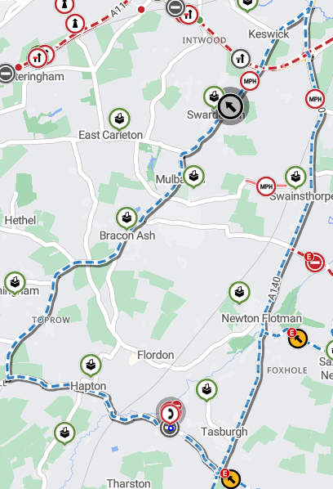

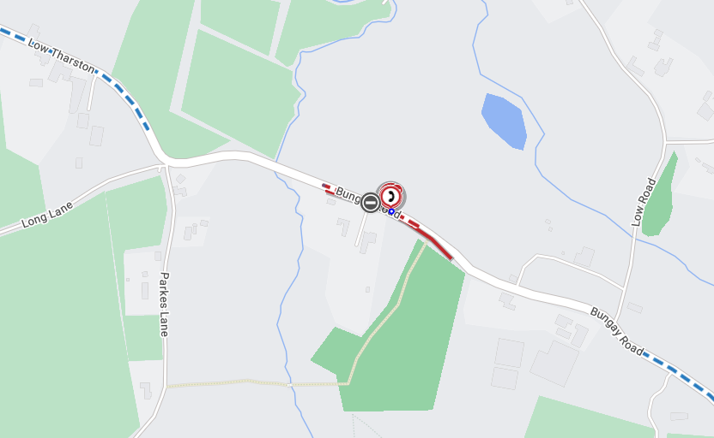

Imagery © 2025 MapTiler | Imagery © 2025 Hexagon | © MapTiler © OpenStreetMap contributors

